Accessible Home Cybersecurity Kit
Skyler Guard, Sarah Maughan, Tyler Vander Mooren
EGR 333W
12/7/2025

I. Problem
In the current day, technology has evolved to be crucial to our everyday lives; phone calls, emails, text-messages, navigation, appointments, even for payment, travel, and access to personal information. The increasing integration of technology into our lives without expanding technological safeguards or education have left our loved ones at risk, especially the elderly population and unknowing youths [1]. The general population is vulnerable to cybersecurity attacks such as identity theft, phishing attempts, and even financial loss from stolen internet services. Many households today rely on smart devices and Wi-Fi networks without understanding how to properly secure their devices. A typical home today has an average of 21 devices connected to the home network [2] "Home networks face an average 10 attacks every 24 hours (Bitdefender)." "99.3% of smart home attacks exploit common vulnerabilities and exposures (Bitdefender)." This lack of cybersecurity awareness, configuration knowledge, and unsafe behaviors or habits leave users vulnerable to privacy breaches, device hijacking, identity theft because they choose weak passwords, lack the skills to identify phishing schemes, and even share personal information they don’t realize is a security risk.
Being literate in cybersecurity threats, risks, and vulnerabilities can be difficult. Understanding how the systems we use on the daily work and in what ways they make us vulnerable requires thorough research. What is the difference between firmware and software? What are ports? How do all of these work, in what ways are these systems vulnerable and what information might someone have access to? The current options aside from a DIY home cybersecurity system are hiring someone educated in cybersecurity to strengthen your safety or buying an expensive cybersecurity product which requires a similar knowledgebase anyway. The combination of information to learn and inaccessible alternatives are intimidating and deter the general population from protecting themselves. Creating a product that will not only protect and educate, but is accessible to the average person in both price and knowledge base is crucial to protecting everyday people from cybersecurity attacks.
II. Research
Hardware Selection
Since one of the goals is accessibility the hardware has to be inexpensive. For this reason a Raspberry Pi will be used for the security hub which typically costs around $15 for the Raspberry Pi Zero W model. “The Raspberry Pi is a very cheap computer that runs Linux, but it also provides a set of GPIO (general purpose input/output) pins, allowing you to control electronic components for physical computing and explore the Internet of Things (IoT)” [3]. The Raspberry Pi Zero W model is smaller than the Pi 5 and has built-in wifi. These features allow the device to be compact and versatile allowing it to be placed in the background without taking up space. In addition to it being compact it will require little setup, work passively and have low power consumption making it more suitable for less technical users. Because of the addition of the wifi module it will be able to scan for devices on the home network, check for vulnerabilities and communicate with the application without having users configure a full router or firewall.
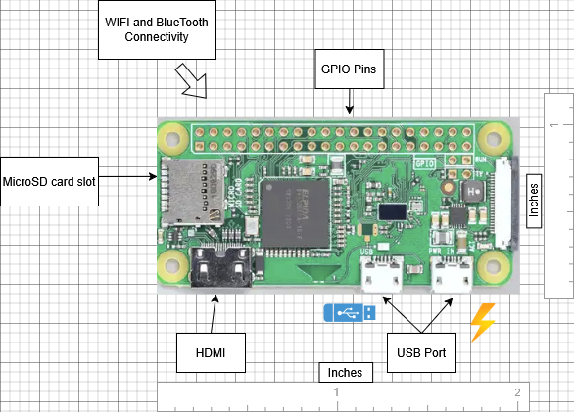
Figure 1. Raspberry Pi Zero W with dimensions and layout.
Common IoT Vulnerabilities
Many consumer IoT vulnerabilities are from weak passwords, outdated firmware and insecure configurations. This often stems from how IoT’s are usually shipped out to consumers, usually with weak default passwords and without automatic security updates making them easy targets for attackers [4]. This creates a huge issue because many users may not recognize these security issues on their own. The security hub will include a wifi scanning module which will work by identifying devices connected to the home network. It will then start checking if the device is running outdated firmware or using an insecure configuration. Since the hub only checks for vulnerabilities it will not be inspecting any user’s content so privacy will not be compromised. Once a vulnerability is detected it will alert the user through the application. In addition it will make use of LED lights on the hub’s enclosure to display system information on the device. Such as power status, connection to wifi, when the hub is scanning and when a vulnerability is found. This is an important feature since, “A lot of recent research indicates that 90% of consumers lack confidence in the safety of their internet devices” [5]. So these LED lights will help serve as a way for the system to communicate with the user without requiring any technical knowledge.
Mobile Application and User Interaction
The primary way the system will communicate with the user will be through the mobile application. This application will allow the user to receive alerts, see vulnerabilities and learn recommended security practices. Many people lack cybersecurity awareness or technical knowledge needed to manage IoT device settings, making many traditional security tools difficult to use [6]. The goal of this application is to address those issues by presenting information in a clear and accessible way so that non-technical users will be able to utilize this information and improve their own security. The application will communicate with the hub to receive information about vulnerabilities it has discovered. When the hub discovers issues such as weak passwords, outdated firmware, bad configurations it will send the mobile application these findings. It will then display the findings in a clear way with step by step guidance on how to resolve the issue or to receive more help. This is in an effort to reduce the difficulty many users face when attempting to follow good security practices like updating devices or turning on security features. Since most people often have limited time to spend on improving their own security or awareness, the application will help alleviate this with recommendations that can be followed quickly and with minimal effort. In addition this application will also include an educational component to provide information to the user on why understanding these vulnerabilities matter. Instead of just reporting the problem to the user, the application will include a brief explanation and tips to encourage safer behavior over time. Additional features will allow users to customize notifications, view their network at a glance and track the status of their devices. These features will help cybersecurity become more approachable by giving users an easier way to view and understand their home network without requiring technical knowledge to do so. The combination of simple design, clear instructions and ongoing educational support will make sure the application remains easy to use while still offering meaningful cybersecurity guidance.
III. Solution
Overview and System Architecture:
The Accessible Home Cybersecurity Kit (AHCK) is an accessible, user-centric, and low-cost system designed to bring comprehensive cybersecurity to home networks. Recognizing the significant vulnerability gap existing in modern home networks, where ‘weakest link’ IoT devices threaten privacy and expose individuals to dangerous cyber threats, the AHCK offers a centralized, automated defense that requires minimal effort and technical expertise to manage and deploy. The solution is composed of three integrated elements: a hardware Hub, a companion mobile application, and a suite of simple physical accessories.
The core objective is to add a comprehensive network-wide, human-readable layer of cybersecurity to the inconsistent cybersecurity protections of individual applications and devices.
The Home Security Hub (HSH):
The Home Security Hub (HSH) is a compact, plug-and-play device designed to be the central enforcement point for the home network. Logically positioned between the existing home router and the broader internet, the HSH mediates all inbound and outbound traffic, allowing it to perform critical, non-intrusive security functions. In addition, the HSH regularly scans network devices for vulnerabilities by performing lightweight, non-malicious penetration tests.
Network Filtering:
Once installed, the HSH acts as a customized firewall that mediates traffic between devices and external networks. This capacity provides two levels of defense:
- Outbound Anomaly Detection: monitors baseline traffic patterns for each device and quarantines traffic sources if a device acts unusually, communicating with known malicious servers or attempting to send unusual amounts of data. This mitigates malware threats before they spread throughout the network.
- Content and Application Filtering: filters suspicious traffic, such as traffic to and from known malicious servers. For users with more technical expertise or special use-cases, the HSH offers multiple configuration presets and customizable white, black, and ‘warning’ lists for IPs and packet types. For example, a user who only accesses a few websites can set up a whitelist for their typical use cases and have stringent security protections for all other traffic. Filter settings can also be configured per-device, so (for example) users can filter all traffic for IoT devices where the users do not require the functionality that uses network connections.
Figure 2. diagram of HSH filtering out malicious packets and forwarding others
HSH
(Network
Filtering
System)
Home Devices
External Networks

Vulnerability Detection:
The HSH executes vulnerability detection by performing recurring scans of all connected devices. This function specifically targets common household-level weaknesses, using similar protocols as hackers to identify and improve vulnerabilities instead of exploiting them.
- Weak Credentials: The HSH will test lists of stolen or common credentials against device login prompts and alert the user if they need to improve their password.
- Outdated Firmware and Software: The HSH will check the device’s reported version against version databases to notify the user when they need to make an update.
- Open Ports and Unnecessary Services: The HSH will perform a port scan on connected devices to identify unnecessary open ports, informing the user about the vulnerability and automatically blocking suspicious traffic.
Crucially, the scanning is conducted automatically and independently, without requiring user expertise or input. In addition, the HSH vulnerability detection protocols are designed to minimize disruption and resource-drain on user devices while they are being used.
User Dashboard:
The user dashboard provides a color-coded overview of home security. Instead of displaying complex log files or security reports, the dashboard presents a clear status (e.g. “Good,” “Needs Improvement,” “High Risk”) with easy-to-understand problem summaries and solutions. The dashboard has four types of communication with users:
- Alerts: alert users to network traffic anomalies and detected vulnerabilities, including a brief colloquial description of the problem, the risks, and how to fix it. Alerts are classified as ‘Yellow,’ ‘Orange,’ or ‘Red’ according to severity.
- Reports: regularly summarize the cybersecurity state of the home network system, including overall system security evaluation (e.g. ‘Good,’ ‘Bad,’ ‘Excellent’), greatest weakness, and a summary of filtered network traffic.
- HSH Logs and Configuration: allow users to change scanning and network filtering settings and view security logs in more detail.
- Learning Resources: tips and guidethroughs to improve user understanding of cybersecurity, inform users about best practices for navigating the internet, and show users in more detail how to implement proposed security solutions, like setting up a password manager or VPN.
Accessories and Physical Control
The included accessories are simple, physical tools designed to give users tangible control independent of device software:
- Privacy Camera Stickers: High quality light-blocking stickers and lens covers that provide a barrier for built-in webcams and smart devices when not in use.
- Outlet Switches: Outlet covers with on and off switches that allow users to physically cut power to high-risk or non-essential smart devices when not in use.
This final component addresses the security concerns related to “black box” smart devices that operate autonomously and often without transparent controls. Physical controls also guarantee privacy and a degree of cybersecurity even after a successful hack has compromised the integrity of digital indicators (such as a ‘camera on’ signal) and software settings.
Timeline
We plan to implement this project over the course of a year, with time to develop the initial hardware and software, build and test a prototype, and integrate feedback into the final product. The attached Gantt chart illustrates the timeline in more detail.
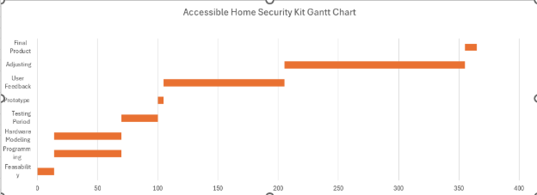
Figure 3. Gantt chart with anticipated project timeline.
Conclusion
The Accessible Home Cybersecurity Kit maintains home privacy and cybersecurity using the Home Security Hub, which scans for vulnerabilities and filters network traffic, the user dashboard, which allows collaboration with users to improve and maintain home cybersecurity, and physical accessories which provide tangible control and alleviate worst-case-scenario risks. Together, these components mitigate the cyber risks associated with ‘weakest link’ devices and applications, and maximize user control over their home cybersecurity without requiring constant management or advanced cybersecurity expertise.
Figure 4. diagram of HSH filtering out malicious packets and forwarding others.
HSH
(Network
Filtering
System)
Home Devices
External Networks
HSH
(Vulnerability Detection)
packets
packets
penetration test
response
Dashboard
information about vulnerabilities
configuration updates
User
alerts, summaries, and tutorials
queries &
configuration updates
perform password and security updates

References
[1] F. Breitinger, J. Ricci, I. Baggilli, “Survey Results on Adults and Cybersecurity Education”,
Education and Information Technologies, vol 24, pp 231-249, Jul 2019, doi: 10.1007/s10639-018-9765-8

[2] Netgear Security Team, “The 2024 IoT Security Landscape Report - NETGEAR”,
Netgear.com, https://www.netgear.com/hub/network/2024-iot-threat-report/

[3] “What is a Raspberry Pi?,” Opensource.com, 2012.
https://opensource.com/resources/raspberry-pi

[4] Fortinet, “What is IoT Security?,” Fortinet, 2022.
https://www.fortinet.com/resources/cyberglossary/iot-security

[5] K. Y. Najmi, M. A. AlZain, M. Masud, N. Z. Jhanjhi, J. Al-Amri, and M. Baz, “A survey on
security threats and countermeasures in IoT to achieve users confidentiality and reliability ,” Materials Today: Proceedings, vol. 44, 2021, https://doi.org/10.1016/j.matpr.2021.03.417.

[6] A. Slonopas, “IoT Cybersecurity: Strengthening Defenses against Threats | American Public
University,”
https://www.apu.apus.edu/area-of-study/information-technology/resources/iot-cybersecurity-strengthening-defenses-against-threats

